ASSIGNMENT D&F W-3
H.T.NO:2303A51022
NAME:K.Srutha keerthi
BATCH-01

Scenario:
An online training platform needs to manage Courses and Enrollments. The
backend must perform CRUD operations and ensure data consistency using
Sequelize.
Assignment: Sequelize – Courses & Enrollments
Name:
Roll No:
Subject:
Date:
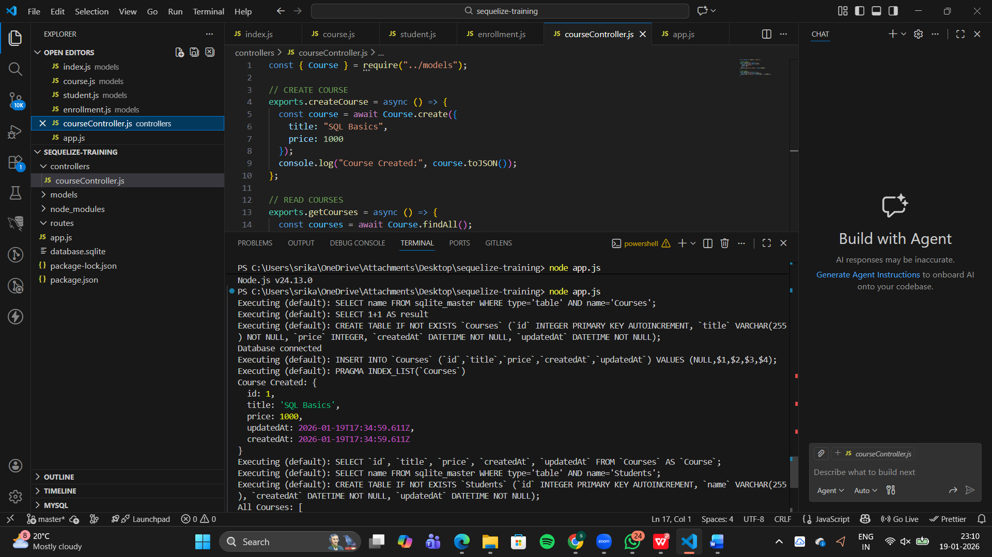
Questions:
1. How would you implement Create, Read, Update, and Delete
operations using Sequelize models?
CRUD operations in Sequelize are implemented using built-in model methods.
- Create is done using create()
- Read is done using findAll() and findByPk()
- Update is done using update()
- Delete is done using destroy()
- 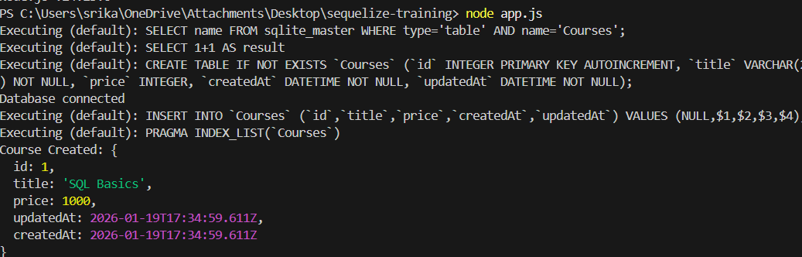

2. How does Sequelize handle data validation and constraints?
Sequelize handles validation and constraints at the model level using properties like allowNull and validate
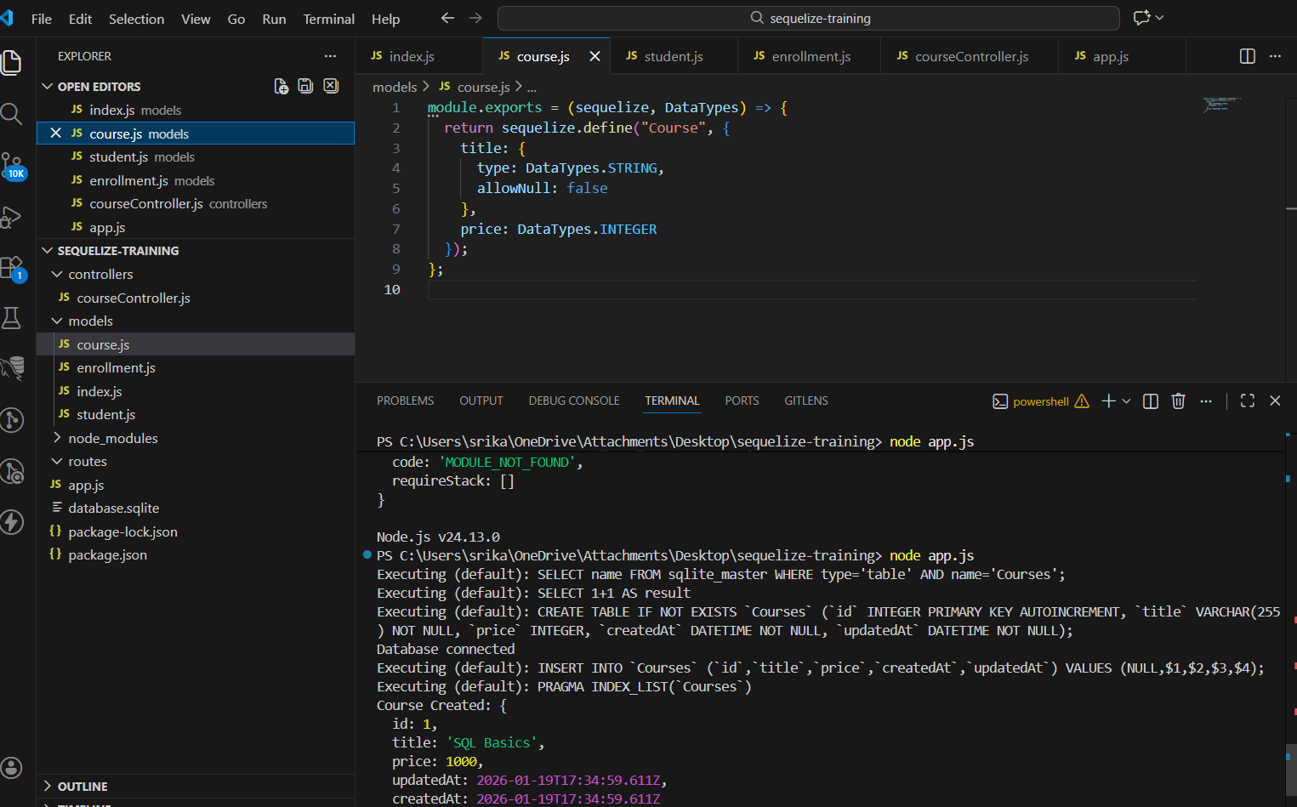
3. How would you define relationships (one-to-many or many-to-many)
between models?
Relationships are defined using Sequelize association methods such as belongsToMany
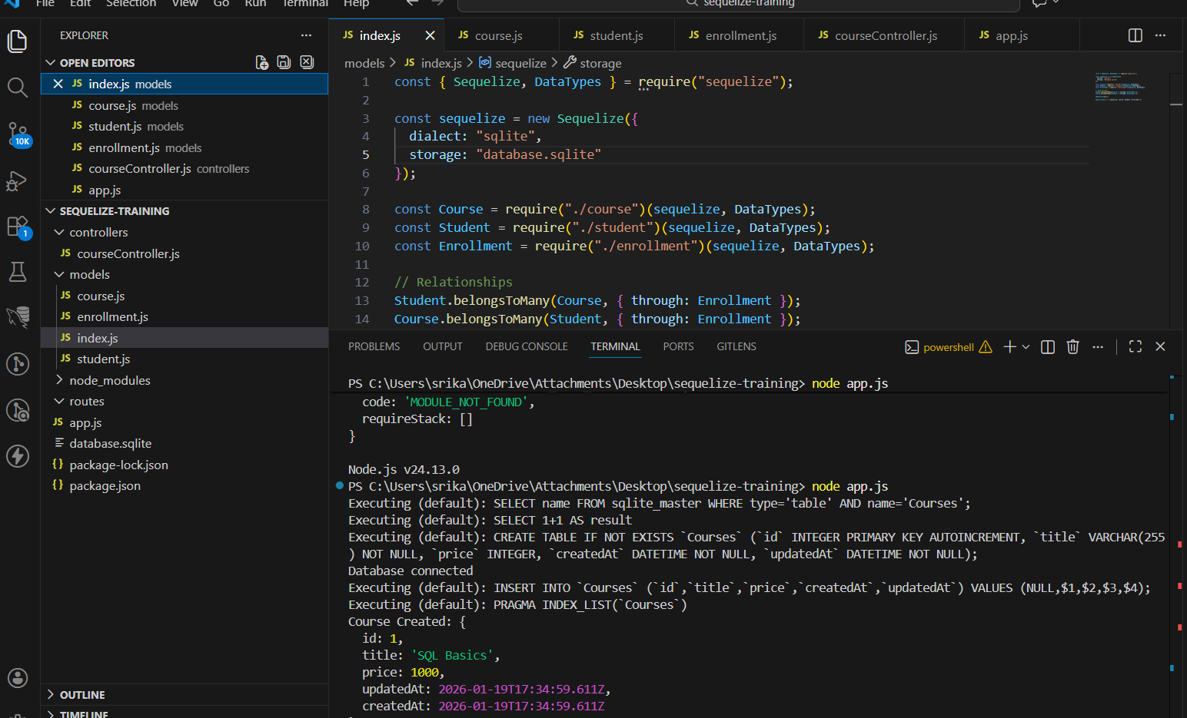
4. What is the role of Sequelize methods like findAll, findByPk, create,
update, and destroy?
These methods perform database operations without writing SQL queries directly.
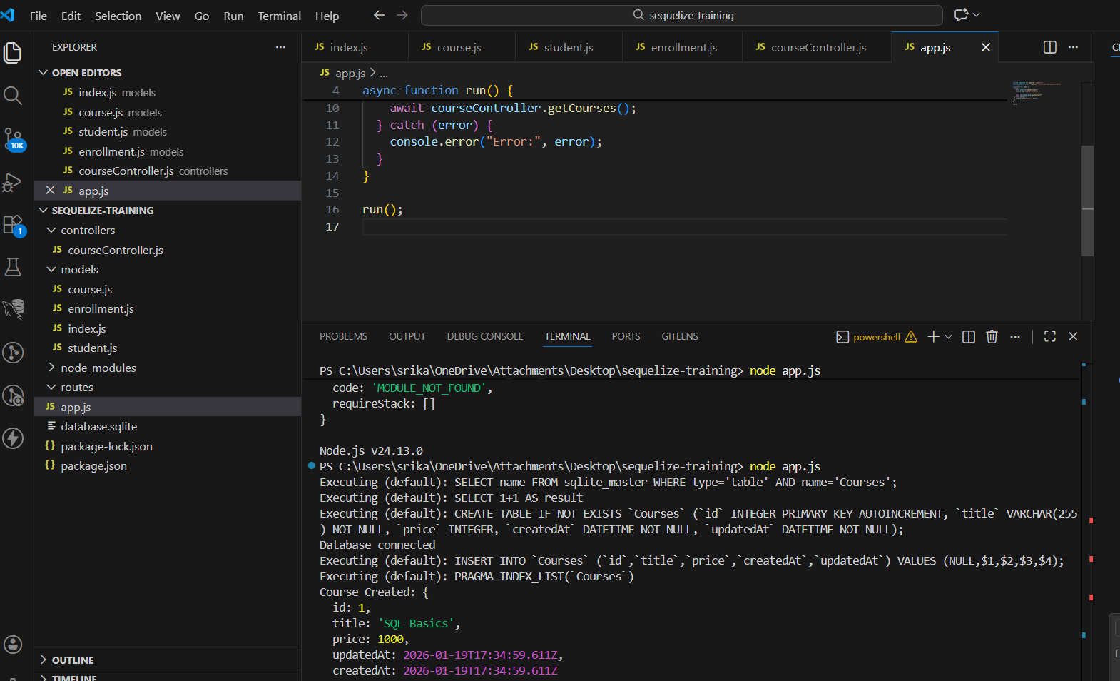
5. How would you handle database errors and exceptions gracefully?
Database errors are handled using try-catch blocks to prevent application crashes.
